October 2026

Diazepam Desitin 5 mg & 10 mg rectal tube – change in tube closure^{1,2}, storage instructions^{1,2} and carton

There has been a production-related change to the opening mechanism of these rectal tubes. Previously the rectal tube had a cap that opened by turning and was then removed. The new rectal tube is fitted with a winged screw cap that is opened by twisting it off.
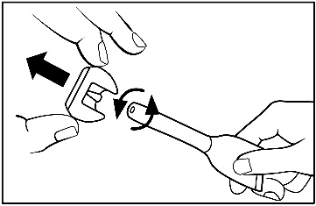
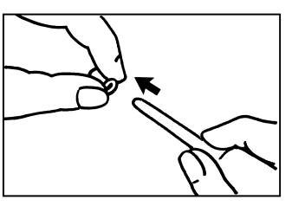

Previous NEW

The current storage instruction "Do not store above 25 °C" no longer applies to the new rectal tube. With the new tubes, no special storage conditions are required.
The outer packaging has also been redesigned as follows:

Previous outer packaging:

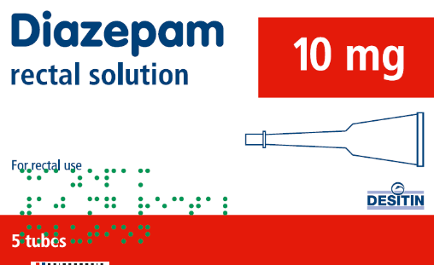
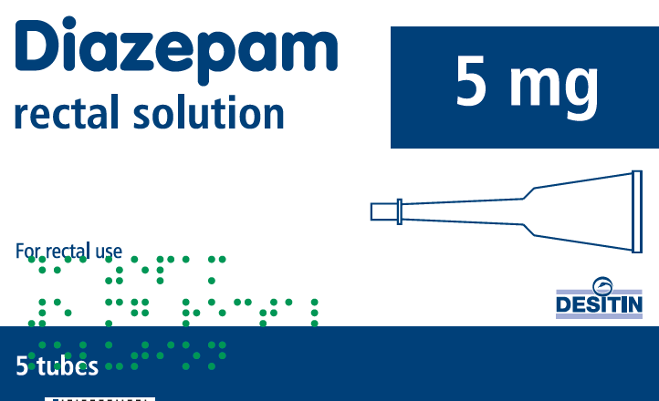

NEW outer packaging:
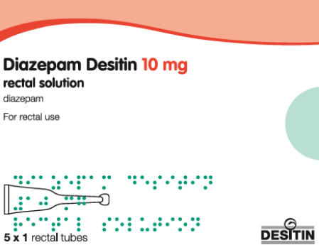
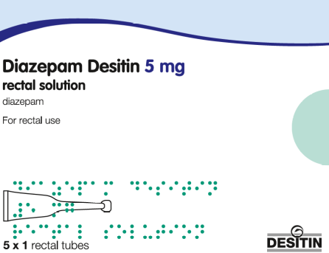

All other characteristics of the product including the active ingredient, strength, composition, therapeutic indication and dosing regimen remain unchanged.
Date of preparation : October 2026
UK-DZ-1926
Should you have any questions or require further information, please do not hesitate to contact us.

References:
- Diazepam Desitin 5 mg Rectal Solution SmPC https://www.medicines.org.uk/emc/product/2997/smpc (last accessed Oct 2026)
- Diazepam Desitin 10 mg Rectal Solution SmPC https://www.medicines.org.uk/emc/product/3001/smpc (last accessed Oct 2026)

